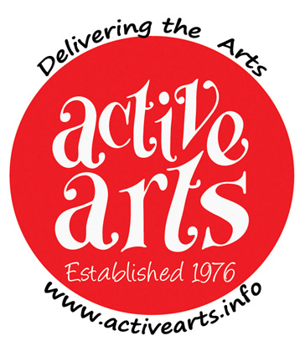 | Active Arts 32nd Annual Art Exhibition  Saturday March 2nd and Sunday March 3rd 2024  10am to 4pm both days at  Countesthorpe Academy, Winchester Road LE8 5PR  Deadline for entries is February 10th 2024
Please complete the following contact information and details of your artwork.
Please keep the TITLE and MEDIA DESCRIPTION as short as possible (24 CHAR MAX)
as they will be printed on small cards to be displayed alongside your works.
Active Arts reserve the right to truncate long titles/media descriptions.
All work should be prepared with hanging string/wire and ready for display on hooks.
Photographs will be taken during the Exhibition, which may be used in future publicity. Work will always be acknowledged where possible.

Up to three works may be entered. The entry fee is £3 per work.

PLEASE USE BLOCK CAPITALS THROUGHOUT

Title _____ Name ___________________________________________________

Postal Address _______________________________________________________

___________________________________________________________________

Landline/Mobile Telephone Number _______________________________________

Email address ________________________________________________________

I would like to enter ___ pieces of work in the 2024 Active Arts Art Exhibition
I have made payment by

Tick one
enclosing a cheque made Payable to ‘Active Arts Group’
making a BACS payment (see below for our account info)
enclosing cash
in the sum of £ ________ as my entry fee.

Account Name:-Active Arts Group
Sort Code:- 08-92-99 Account Number:- 65274583
Please reference BACS payments thus:- Artex <name> e.g. Artex N Other.

I agree to be contacted by viewers who are interested in my work YES / NO

Signed:- ____________________________ Date:- ____________________

Please complete details of your work(s) overleaf.
Include dimensions if any are larger than 50cm in any direction.

Continued -

1) | Title
 | Media Description
 | Selling Price (or NFS)
2) | Title
 | Media Description
 | Selling Price (or NFS)
3) | Title
 | Media Description
 | Selling Price (or NFS)

Titles and media description to be 24 characters max. (including spaces)

I understand that every effort to ensure security of my work will be taken but that Active Arts cannot accept responsibility for loss or damage.
You may offer your works for sale and if sold, a commission of 10% will be levied.

Please deliver your work to Countesthorpe Academy between 4.15pm and 5.45pm on Friday March 1st. You will be given a receipt which you must retain as it will be needed to collect unsold works after the event.

Please send your completed form to: -
John Fawcett 16 Pinewood Close, Countesthorpe, Leicester LE8 5TS
If you’ve paid by BACS you can scan and send your form by email to activearts23@hotmail.com

Any problems? If you need confirmation that your entry has been received or for any problem call 0116 2779193 and someone will get back to you.

Your cheque for entering may not be banked until after the Exhibition.

Payment to artists for sold works will be made around the 13th March.
Active Arts would prefer to pay you by BACS, which allows us to make a direct payment to your back account. We are bound by the Data Protection Act so we shall not share your details with any other third party, organisation or company.

If you agree to be paid by BACS please fill in the details below.

Name on Account ________________________________________________
Sort code ______________ Account number ______________________

Unsold works to be collected between 4.20 and 5.30 on Sunday 3rd March

