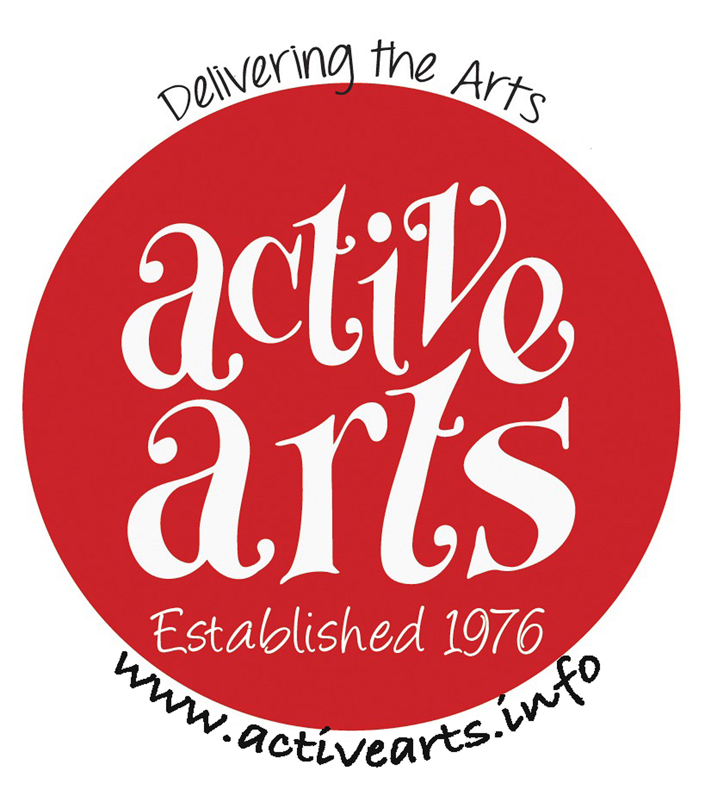 ACTIVE ARTS 31st ANNUAL ART EXHIBITION
Saturday March 4th 10am -4pm Sunday March 5th 10am -4pm
At Countesthorpe Academy
Winchester Road Countesthorpe LE8 5PR

Please complete the following details of your artwork, keeping MEDIA and TITLES as short as possible as they will be printed on small cards to be displayed alongside your works.
Active Arts reserve the right to edit long title/media descriptions.
All work should be prepared and ready for display.

Name
Address

Telephone No. __
Email address __

1) Description (medium) __
Title __
Selling Price

2) Description (medium) __
Title __
Selling Price

3) Description (medium) __
Title __
Selling Price

The fee for each piece of art is £3.00 TOTAL £ _______

Cheques should be made payable to Active Arts.

If you use BACS please use ARTEX before your name as an identifying code.

I understand that every effort to ensure security of my work will be taken but that Active Arts cannot accept responsibility for loss or damage.
You may offer your works for sale and if sold, a commission of 10% will be levied.

Photographs will be taken during the Exhibition which may be used in future publicity. Work will always be acknowledged where possible.
Please deliver your work to the Academy between 3.30pm and 6.00pm on Friday March 3rd
You will be given a receipt.

Signed ___________________________ Date__________________________

Please send completed form along with your cheque made out to ‘Active Arts’ to: -

John Fawcett 16 Pinewood Close, Countesthorpe, Leicester LE8 5TS
Deadline for entries is Feb.11th 2023

Or send an email to activearts23@hotmail.com Do you agree to be contacted by viewers who are interested in your work,
YES or NO

Any problems? If you need confirmation that your entry has been received or for any problem call 0116 2779193 and someone will get back to you.

To Artists

Your cheque for entering will not be cashed until after the Exhibition.

Payment to artists for sold works will be made around the 13th March
Active Arts very much prefer to pay by BACS which allows us to make a direct payment to your back account

We are bound by the Data Protection Act so we shall not
share your details with any other third party, organisation or
company.

If you agree to be paid by BACS please fill in the details below.

6 digit sort code __________

Account number ________________

Name on the Account

--------------------------------------------------------------------------------------------------------------------

To Pay via BACS you will need the Active Arts details

Active Arts BACS details

Account name Active Arts Group
Sort Code 089299
Account Number 65274583

