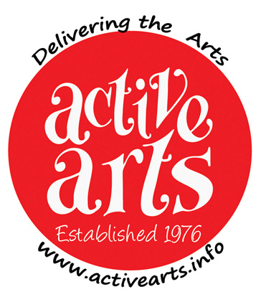 | Active Arts 34th Annual Art Exhibition  Saturday February 28th and Sunday March 1st 2026  10am to 4pm both days at  Countesthorpe Academy, Winchester Road LE8 5PR  Deadline for entries is February 7th 2026
Please complete the following contact information and details of your artwork.
Please keep the TITLE and MEDIA / DESCRIPTION as short as possible (Max 24 characters ie letters, numbers, spaces between words), as they will be printed on small cards to be displayed alongside your works.
Active Arts reserve the right to truncate long titles/media descriptions.
All work to be hung must be submitted with securely fitted eyes and hanging string/wire, ready for display on hooks.
Photographs will be taken during the Exhibition, which may be used in future publicity. Work will always be acknowledged where possible.

Up to three works may be entered. The entry fee is £3 per work.

PLEASE COMPLETE THE INFORMATION BELOW IN LEGIBLE BLOCK CAPITALS

Title _____ Name ___________________________________________________

Postal Address _______________________________________________________

___________________________________________________________________

Landline/Mobile Telephone Number _______________________________________

Email address ________________________________________________________

I would like to enter ___ pieces of work in the 2026 Active Arts Art Exhibition
I have made payment by

Tick one
enclosing a cheque made Payable to ‘Active Arts Group’
making a BACS payment (see below for Active Arts’ account info)
enclosing cash
in the sum of £ ________ as my entry fee.

Account Name:- Active Arts Group
Sort Code:- 08-92-99 Account Number:- 65274583
Please reference BACS payments thus:- Artex <name> e.g. Artex N Other.

I agree to be contacted by viewers who are interested in my work YES / NO

Signed:- ____________________________ Date:- ____________________

Please complete details of your work(s) overleaf.
Include dimensions if any are larger than 50cm/20” in any direction.
Continued –
PLEASE COMPLETE THE INFORMATION BELOW IN LEGIBLE BLOCK CAPITALS

1) | Title
 | Medium / Description
 | Selling Price (or NFS) |  | Size | x cm/inch
2) | Title
 | Medium / Description
 | Selling Price (or NFS) |  | Size | x cm/inch
3) | Title
 | Medium / Description
 | Selling Price (or NFS) |  | Size | x cm/inch

Titles and Medium / Description to be a maximum of 24 characters (i.e. letters, numbers, spaces between words) long, so that each will fit on one line of the labels.
You may offer your works for sale and if sold, a commission of 10% will be levied.

You acknowledge that every effort will be made to ensure security of the work, but accept and agree that Active Arts will not be held responsible for loss or damage.

Please deliver or send your completed form to: -
Active Arts ArtEx, 4 New Street, Countesthorpe, Leicester LE8 5RA.
If you’ve paid by BACS you can instead scan and send your form by email to bvwells1964@hotmail.co.uk

Any problems? If you need confirmation that your entry has been received or for any problem call 07549 631469 and leave a message. Someone will get back to you.

Your cheque for entering may not be banked until after the Exhibition.

Please deliver your work to Countesthorpe Academy between 4.30pm and 5.45pm on Friday February 27th. You will be given a receipt which you must retain as it will be needed to collect unsold works after the event.

Payment to artists for sold works will be made around the 7th March.
Active Arts would prefer to pay you by BACS, which allows us to make a direct payment to your back account. We are bound by the Data Protection Act so we shall not share your details with any other third party, organisation or company.

If you agree to be paid by BACS please fill in the details below.

Name on Account ________________________________________________
Sort code ______________ Account number ______________________

Unsold works to be collected between 4.20 and 5.15 on Sunday 1st March

